EXPERIMENT 11
Simulation and Performance Evaluation of OFDM and FBMC Wireless Waveforms
Aim
To generate OFDM and FBMC-style multicarrier waveforms in MATLAB, compare their power spectral density (PSD), measure peak-to-average power ratio (PAPR), and study their spectral characteristics.
Procedure
- Open MATLAB and create a script named Exp11_OFDM_FBMC.m.
- Set the total number of subcarriers to 64 and active subcarriers to 12.
- Set the OFDM cyclic prefix length to 16 samples and the number of symbols to 100.
- Generate random binary data and map it to QPSK symbols.
- Generate the OFDM waveform using IFFT and add a cyclic prefix to each symbol.
- Generate a filtered multicarrier comparison waveform using a prototype filter.
- Calculate the PAPR of each waveform.
- Estimate the PSD using the periodogram method.
- Plot the PSD curves and compare the out-of-band spectral leakage.
- Record the measured PAPR values and explain the differences.
MATLAB Program
clc;
clear;
close all;
rng(42);

N = 64; % Total subcarriers
M = 12; % Active subcarriers
Ncp = 16; % Cyclic prefix
Nsym = 100; % Number of symbols

active = (N/2-M/2+1):(N/2+M/2);

% Generate QPSK data
bits = randi([0 1],2*M,Nsym);
symbols = ((1-2*bits(1:2:end,:)) + ...
1i*(1-2*bits(2:2:end,:)))/sqrt(2);

ofdm = [];

% OFDM waveform generation
for s = 1:Nsym
X = zeros(N,1);
X(active) = symbols(:,s);
x = ifft(X)*sqrt(N);
xcp = [x(end-Ncp+1:end); x];
ofdm = [ofdm; xcp];
end

% Simplified filtered multicarrier comparison waveform
% This is a teaching approximation, not a complete FBMC-OQAM implementation.
prototype = fir1(64,0.25);
filtered = filter(prototype,1,ofdm);
filtered = filtered/(sqrt(mean(abs(filtered).^2))+eps);
ofdm = ofdm/(sqrt(mean(abs(ofdm).^2))+eps);

% Calculate PAPR
paprOFDM = 10*log10(max(abs(ofdm).^2)/mean(abs(ofdm).^2));
paprFiltered = 10*log10(max(abs(filtered).^2)/mean(abs(filtered).^2));

fprintf('OFDM PAPR = %.3f dB\n',paprOFDM);
fprintf('Filtered waveform PAPR = %.3f dB\n',paprFiltered);

% PSD estimation
[P1,f1] = periodogram(ofdm,[],2048,1,'centered');
[P2,f2] = periodogram(filtered,[],2048,1,'centered');

figure;
plot(f1,10*log10(P1/max(P1)+eps),'r');
hold on;
plot(f2,10*log10(P2/max(P2)+eps),'b');
grid on;
xlabel('Normalized Frequency');
ylabel('Relative PSD (dB)');
title('OFDM and Filtered Multicarrier PSD Comparison');
legend('OFDM','Filtered Multicarrier');
ylim([-80 5]);

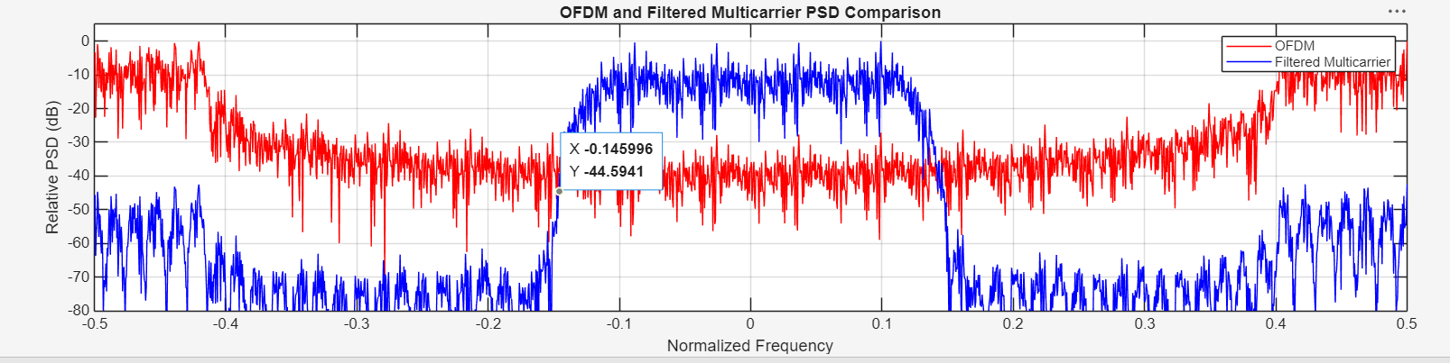

Result
The OFDM waveform and a filtered multicarrier comparison waveform were generated. Their PAPR values and PSD curves were calculated and plotted. Record the values produced by MATLAB and compare the observed spectral leakage.

